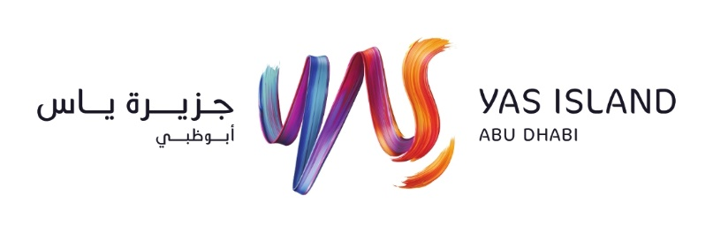
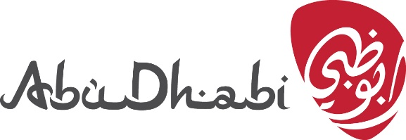

MICHAEL MCINTYRE RETURNS TO THE UAE!

TO BE ANNOUNCED WEDNESDAY 7TH APRIL 8AM UAE

Abu Dhabi 6th April 2021 - GME Events, in conjunction with the Abu Dhabi Department of Culture and Tourism, and Yas Island, Abu Dhabi’s leading entertainment hub, is set to bring the internationally renowned British Comedian Michael McIntyre to Abu Dhabi for the first time. The show will take place on Friday 16 July at the newly opened Etihad Arena on Yas Island, marking the beginning of events resuming on the island.

Michael is one of the most recognizable comedians in the world, and his most recent ‘Big World Tour’ saw 250 sold-out shows consisting of almost one million tickets sales across 20 countries. He is an English Comedian, Writer & TV Presenter and most recently released his headline Netflix special which was one of Netflix’s most-watched Comedy shows in 2020.

“I can’t wait to perform my Greatest Hits show at the Etihad Arena, Yas Island in July. This will be my first time in Abu Dhabi & I am excited to be the first performer announced to play this venue!” Michael says.

Yas Island one of the world’s fastest growing leisure and entertainment destinations, offers visitors a diverse mix of award-winning leisure and entertainment experiences, from one-of-a-kind theme parks, world-class shopping and superb dining, to a links golf course, exciting water and motor sports, and spectacular musical, entertainment and family events… all within the 25 sq km Island.

Precautionary measures are in place to ensure the health and safety of visitors to the Yas Island. More information on precautionary measures taken at Yas Island are available on yasisland.ae/yaswellness.

Tickets are immediately available from www.etihadarena.ae and priced from AED195. Tickets will be available to purchase in groups of 2s, 3s & 4s only.
Ticket packages including Concert Ticket & Hotel stay for those travelling to Yas Island will be available soon.

For any further requests please reach out to contact@gme-events.com

About Yas Island

Yas Island is one of the world’s fastest growing leisure and entertainment destinations, located on the golden shores of Abu Dhabi - just 20 minutes from downtown Abu Dhabi and 50 minutes from Dubai. Yas Island offers holiday makers a diverse mix of award-winning leisure and entertainment experiences, from one-of-a-kind theme parks, world-class shopping and superb dining, to a links golf course, exciting water and motor sports, and spectacular musical, entertainment and family events… all within the 25 sq km Island. Today, Yas Island is home to the award-winning theme parks Ferrari World Abu Dhabi, Yas Waterworld, Warner Bros. World Abu Dhabi, the record-breaking CLYMB™ Abu Dhabi, Yas Marina Circuit (home to the FORMULA 1 ETIHAD AIRWAYS ABU DHABI GRAND PRIX™), Yas Marina, the award-winning Yas Links golf course, as well as Abu Dhabi’s largest mall, Yas Mall. With hotels, including W Abu Dhabi - Yas Island, Hilton Abu Dhabi Yas Island, Crowne Plaza Yas Island Abu Dhabi, Centro Yas Island by Rotana, Radisson Blu Hotel Abu Dhabi Yas Island, Park Inn by Radisson Hotel Abu Dhabi Yas Island and Staybridge Suites Abu Dhabi Yas Island, plus more than 165 dining experiences, the destination also features indoor and outdoor concert venues including MAD and Etihad Arena - all of which are complemented by a range of visitor services that connect all attractions to one another.

For more information visit www.yasisland.ae

